41.8: 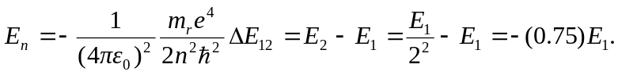
a) 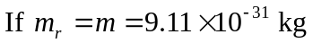
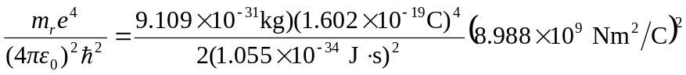
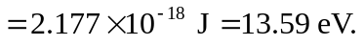
For 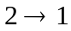 transition, the coefficient is (0.75)(13.59 eV)=10.19 eV.
b) If 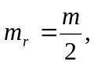 using the result from part (a),
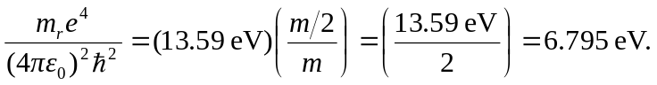
Similarly, the transition, 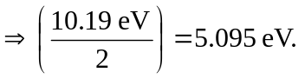
c) If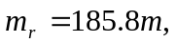 using the result from part (a),
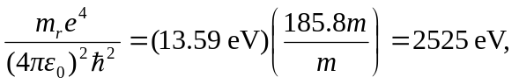
and the transition gives(10.19 eV)(185.8)=1893 eV.

